Response Weight (g) S. acutus & tabernaemontani with seeds
Whole Model
Actual by Predicted Plot
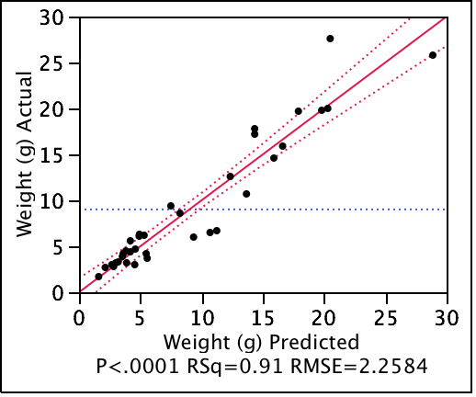

Summary of Fit
RSquare | 0.906149
RSquare Adj | 0.900283
Root Mean Square Error | 2.258402
Mean of Response | 9.017143
Observations (or Sum Wgts) | 35

Analysis of Variance
Source | DF | Sum of Squares | Mean Square | F Ratio
Model | 2 | 1575.8376 | 787.919 | 154.4824
Error | 32 | 163.2121 | 5.100 | Prob > F
C. Total | 34 | 1739.0497 |  | <.0001*

Parameter Estimates
Term |  | Estimate | Std Error | t Ratio | Prob>|t|
Intercept |  | -1.85853 | 1.059033 | -1.75 | 0.0888
Stem lgth (cm) |  | 0.0385071 | 0.00799 | 4.82 | <.0001*
Vol |  | 0.0322009 | 0.004826 | 6.67 | <.0001*

Residual by Predicted Plot
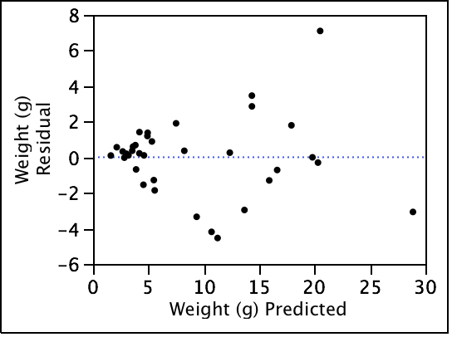

Stem lgth (cm)
Leverage Plot
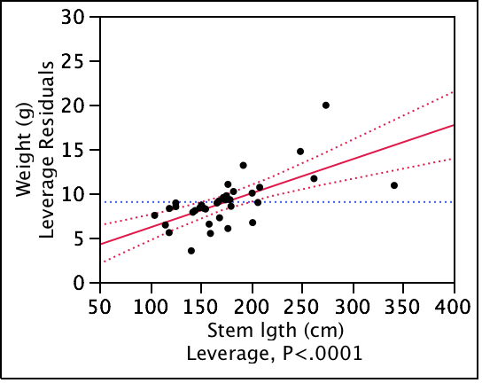
Vol
Leverage Plot
